HW 2

You can make a graph on the different models and the different accuracies

First try to find an outline for the problem

Input

List of models ans list of hyperparameters

For each classifier build a parameter grid

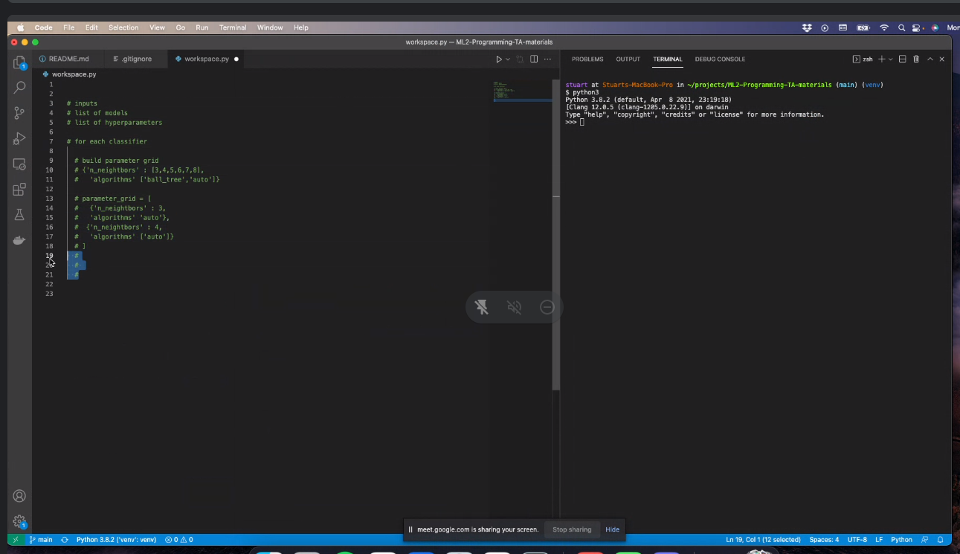

You can do <https://scikit-learn.org/stable/modules/generated/sklearn.model_selection.ParameterGrid.html>

Each set will be through a for loop

Then do a cross validation and find a metric

Append accuracy on the scores list

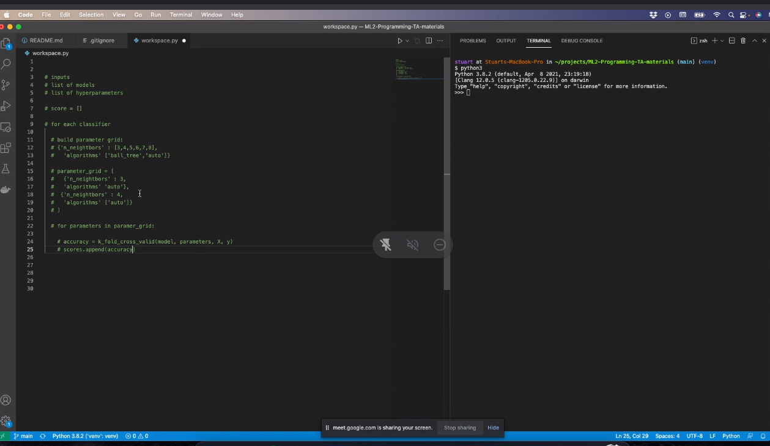

<https://scikit-learn.org/stable/modules/generated/sklearn.model_selection.KFold.html>

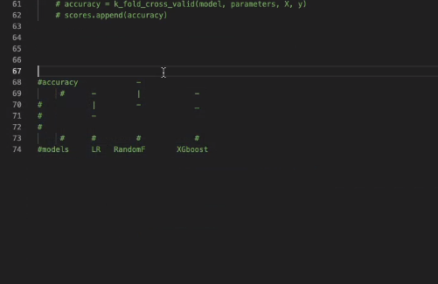

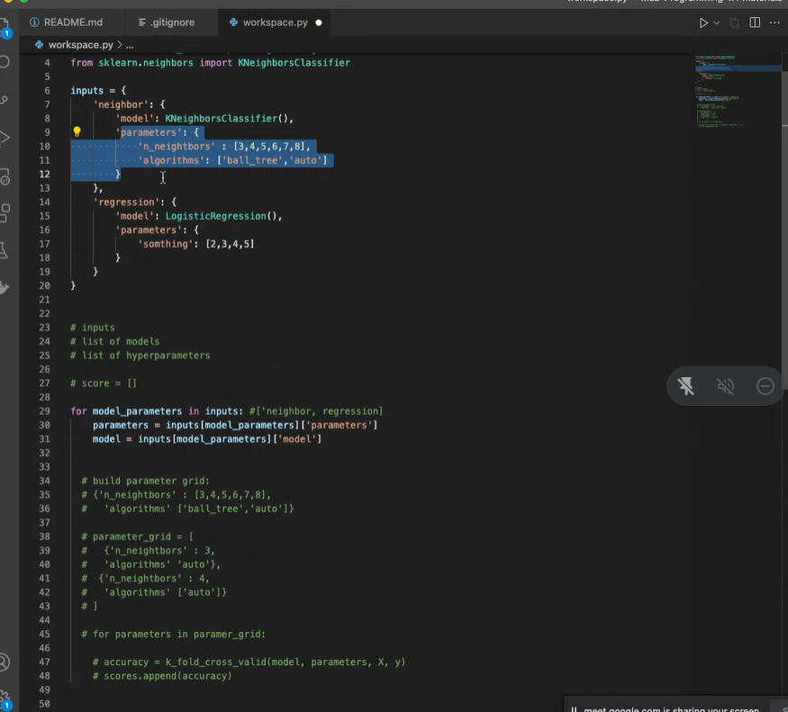

To read in data <https://realpython.com/python-csv/>

You can also use the data in scikit learn

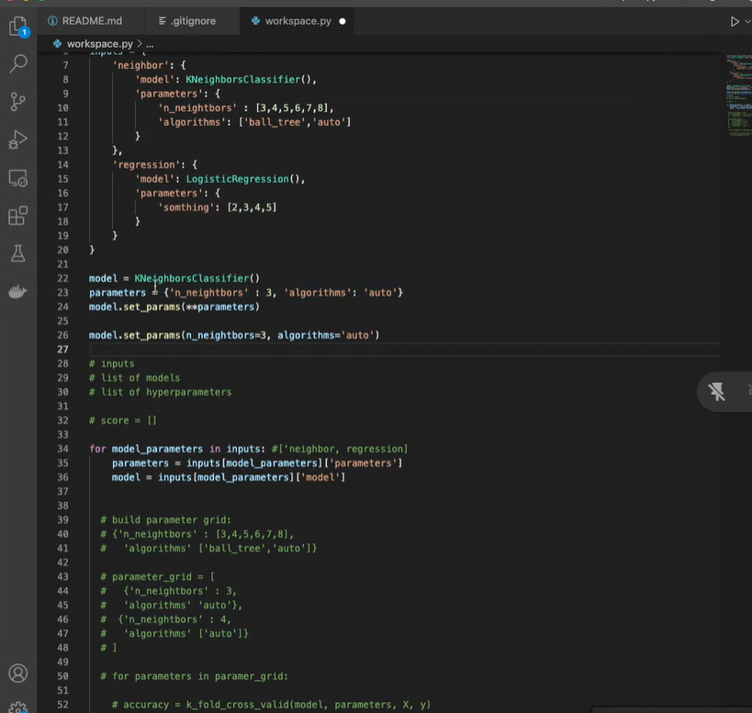

Option to adding the models

